PSHE (Personal, Social, Health Education) Policy
Including Relationships and Health Education
Name of school: King George V Primary
Date of policy: September 2023
Member of staff responsible: G Cowley
Review date: October 2024
Intent
At King George V Primary School, we want to provide all of our pupils with the best possible education, opportunities and environment. PSHE is central to developing our whole school ethos and one way in which we promote our School Values; Respect, Pride, Responsibility, Ambition and Courage.
All of our members of staff pride themselves on knowing our pupils and families really well. This allows us to build good relationships with all of the pupils we teach and so, we can best support our pupils to develop holistically.
Implementation
We teach Personal, Social, Health Education as a whole-school approach to underpin children’s development as people and because we believe that this also supports their learning capacity. This mindful approach to PSHE allows us to ensure progression and a spiral curriculum. The mapping document: Jigsaw 3-11 and statutory Relationships and Health Education, shows exactly how Jigsaw and therefore our school, meets the statutory Relationships and Health Education requirements.
The Jigsaw Programme offers us a comprehensive, carefully thought-through Scheme of Work which brings consistency and progression to our children’s learning in this vital curriculum area.
There are 6 themes of JIGSAW:
1. Being Me in My World
2. Celebrating Difference
3. Dreams and Goals
4. Healthy Me
5. Relationships
6. Changing Me
To ensure that a wide range of topics are covered in depth throughout our curriculum, we also provide learning opportunities based on different events during the year: Mental Health Week, NSPCC PANTS, Anti-bullying Week and Safer Internet Day.
Teachers should respond to the needs of their classes by adapting planning and providing targeted lessons to support the children in circumstances such as bullying, e-safety and wellbeing.
PSHE can also link in with other subjects, for example:
- Art and Music – understanding cultural significance and traditions worldwide
- Geography – on impact on the wider world and becoming global citizens
- Science – understanding how to care for our bodies, both mentally and physically
- RE – showing compassion and caring for others regardless of faith
We also develop PSHE through activities and whole-school events, e.g., the school council meets regularly to discuss school matters. We offer residential visits to Year 3 and 4 children where there is a particular focus on developing pupils’ self-esteem, giving them opportunities to develop leadership, co-operative skills and effective discussion through team-building activities.
We include the statutory Relationships and Health Education within our whole-school PSHE Programme. For instance, as part of the Relationships and Changing Me units of work there is a strong safeguarding focus in particular. As a school community we want to grow resilience and positive self- esteem and confidence our pupils, so they can recognise when they feel uncomfortable in a situation and know who to trust and how to speak up for help. We want children to respect themselves and their bodies and know what healthy relationships feel like.
At King George V, we allocate one hour to PSHE each week in order to teach the PSHE knowledge and skills in a developmental and age-appropriate way. These explicit lessons are reinforced and enhanced in many ways:
- Assemblies, praise assemblies and reward system
- Through relationships child to child, adult to child and adult to adult across the school.
- We aim to ‘live’ what is learnt and apply it to everyday situations in the school community.
Class teachers deliver the weekly lessons to their own classes.
Relationships Education
‘Today’s children and young people are growing up on an increasingly complex world and living their lives seamlessly on and offline. Children and young people need to know how to be safe and healthy, and how to manage their academic, personal and social lives in a positive way.’ - DfE Guidance on Relationships Education, Sex Education and Health Education 2019
RSE is taught within the personal, social, health education (PSHE) curriculum and our Jigsaw curriculum. RSE is about the emotional, social and cultural development of pupils, and involves learning about relationships, sexual health, sexuality, healthy lifestyles, diversity and personal identity. RSE involves a combination of sharing information and exploring issues and values.
RSE is not about the promotion of sexual activity.
Relationships Education in primary schools will cover ‘Families and people who care for me’, ‘Caring friendships’, ‘Respectful relationships’, ‘Online relationships’, and ‘Being safe’ (see appendix2). The way the Jigsaw Programme covers these is explained in the mapping document (appendix 1): Jigsaw 3-11 and Statutory Relationships and Health Education. It is important to explain that whilst the Relationships Unit in Jigsaw covers most of the statutory Relationships Education, some of the outcomes are also taught elsewhere in Jigsaw e.g., the Celebrating Difference Puzzle helps children appreciate that there are many types of family composition and that each is important to the children involved. This holistic approach ensures the learning is reinforced through the year and across the curriculum.
As part of their RHE learning, children are taught, in an age- appropriate way about consent. At a basic level, consent means asking for and waiting to hear a ‘yes’. Consent is seeking and giving permission. Pupils are taught that if one friend wants to borrow something from another friend, they must get permission. If one friend wants to hug their friend, they should check if their friend is okay with that first. Furthermore, pupils will be taught to understand that only certain people need to see or touch certain parts of their body, at certain times. They also learn to understand who to speak to if they have any concerns about inappropriate touch. Through-out KS2, pupils also develop their understanding of healthy, respectful relationships. This includes friendships, online relationships and relationships with family members. Teaching pupils about consent and healthy relationships is imperative to helping us safeguard pupils, as well as pupils recognising how to safeguard themselves.

Health Education
Health Education in primary schools will cover ‘Mental wellbeing’, ‘Internet safety and harms’, Physical health and fitness’, Healthy eating’, ‘Drugs, alcohol and tobacco’, ‘Health and prevention’, ‘Basic First Aid’, ‘Changing adolescent body’. The way the Jigsaw Programme covers these is explained in the mapping document: Jigsaw 3-11 and Statutory Relationships and Health Education. It is important to explain that whilst the Healthy Me unit in Jigsaw covers most of the statutory Health Education, some of the outcomes are taught elsewhere in Jigsaw e.g., Emotional and mental health is nurtured every lesson through the Calm me time, social skills are grown every lesson through the Connect us activity and respect is enhanced through the use of the Jigsaw Charter. Also, teaching children about puberty is now a statutory requirement which sits within the Health Education part of the DfE guidance within the ‘Changing adolescent body’ strand, and in Jigsaw this is taught as part of the Changing Me Puzzle (unit). Again, the mapping document shows how the Jigsaw whole-school approach spirals the learning and meets all statutory requirements and more.
Sex Education
The DfE Guidance 2019 recommends that all primary schools ‘have a sex education programme tailored to the age and the physical and emotional maturity of the pupils.’
However, ‘Sex Education’ is not compulsory in primary schools and parents have the right to withdraw their children from these lessons. It is worth noting that the right to withdraw only applies to the optional aspects of sex education and not the statutory aspects of Health Education, e.g., pubertal changes. Schools are free to determine the content of sex education at primary school but with the aim that it, “should ensure that both boys and girls are prepared for the changes that adolescence brings and – drawing on knowledge of the human life cycle set out in the national curriculum for science - how a baby is conceived and born”.
At King George V Primary School, there are no additional/optional sex education lessons. This means that there are no lessons which parents/carers have to decide to withdraw their child from or not. This decision was taken because pubertal changes are taught as a statutory requirement of Health Education in Y5 at our school and reproduction is covered as part of the Science curriculum in Y6. Therefore, we feel that the children will develop an understanding of the scientific part of human development through these lessons and an understanding of the emotional aspects of relationships through PSHE. We do not consider that any further understanding is necessary at primary level and that parents/carers have the discretion to share any further knowledge at this age if they wish to.
Subject Leaders and members of the Senior Leadership Team will;
- Collect pupil voice
- Learning walks and observations
- Book scrutinises
- Planning checks
Assessment and Record-keeping
Every pupil has their own PSHE book where evidence is gathered. Evidence can include written work, group work, photographs or work created using ICT. Teachers complete an assessment grid at the end of each unit of work providing judgements for each pupil, as to whether they are working towards or working at the expected standard for PSHE. Teachers also track how our pupils demonstrate our school values; respect, responsibility, courage, ambition and pride. This is completed termly.

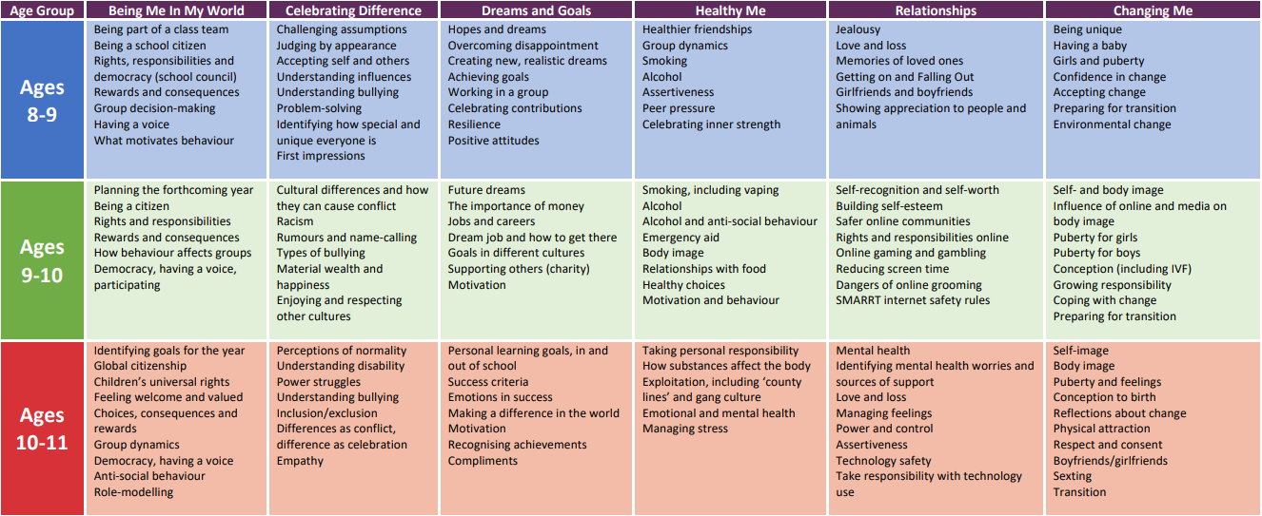
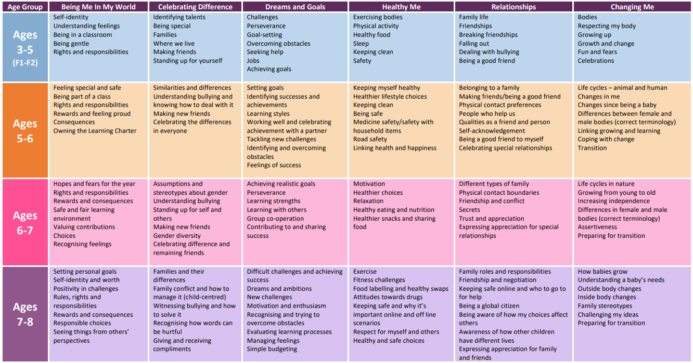
Jigsaw Mapping Overview (Appendix 1)

Relationship DfE guidance – Appendix 2
Topic | Pupils should know
Families and people who care about me | - That families are important for children growing up because they can give love, security and stability  - The characteristics of healthy family life, commitment to each other, including in times of difficulty, protection and care for children and other family members, the importance of spending time together and sharing each other’s lives  - That others’ families, either in school or in the wider world, sometimes look different from their family, but that they should respect those differences and know that other children’s families are also characterised by love and care  - That stable, caring relationships, which may be of different types, are at the heart of happy families, and are important for children’s security as they grow up  - That marriage represents a formal and legally recognised commitment of two people to each other which is intended to be lifelong  - How to recognise if family relationships are making them feel unhappy or unsafe, and how to seek help or advice from others if needed
Caring friendships | - How important friendships are in making us feel happy and secure, and how people choose and make friends  - The characteristics of friendships, including mutual respect, truthfulness, trustworthiness, loyalty, kindness, generosity, trust, sharing interests and experiences and support with problems and difficulties  - That healthy friendships are positive and welcoming towards others, and do not make others feel lonely or excluded  - That most friendships have ups and downs, and that these can often be worked through so that the friendship is repaired or even strengthened, and that resorting to violence is never right  - How to recognise who to trust and who not to trust, how to judge when a friendship is making them feel unhappy or uncomfortable, managing conflict, how to manage these situations and how to seek help or advice from others, if needed
Respectful relationships | - The importance of respecting others, even when they are very different from them (for example, physically, in character, personality or backgrounds), or make different choices or have different preferences or beliefs  - Practical steps they can take in a range of different contexts to improve or support respectful relationships  - The conventions of courtesy and manners  - The importance of self-respect and how this links to their own happiness  - That in school and in wider society they can expect to be treated with respect by others, and that in turn they should show due respect to others, including those in positions of authority  - About different types of bullying (including cyberbullying), the impact of bullying, responsibilities of bystanders (primarily reporting bullying to an adult) and how to get help  - What a stereotype is, and how stereotypes can be unfair, negative or destructive  - The importance of permission-seeking and giving in relationships with friends, peers and adults
Online relationships | - That people sometimes behave differently online, including by pretending to be someone they are not  - That the same principles apply to online relationships as to face-to face relationships, including the importance of respect for others online including when we are anonymous  - The rules and principles for keeping safe online, how to recognise risks, harmful content and contact, and how to report them  - How to critically consider their online friendships and sources of information including awareness of the risks associated with people they have never met  - How information and data is shared and used online
Being safe | - What sorts of boundaries are appropriate in friendships with peers and others (including in a digital context)  - About the concept of privacy and the implications of it for both children and adults; including that it is not always right to keep secrets if they relate to being safe  - That each person’s body belongs to them, and the differences between appropriate and inappropriate or unsafe physical, and other, contact  - How to respond safely and appropriately to adults they may encounter (in all contexts, including online) whom they do not know  - How to recognise and report feelings of being unsafe or feeling bad about any adult  - How to ask for advice or help for themselves or others, and to keep trying until they are heard  - How to report concerns or abuse, and the vocabulary and confidence needed to do so  - Where to get advice e.g., family, school and/or other sources

